Physics Year 12: Formulae and Constants Sheet

Reproduced by kind permission of The Curriculum Council

Area of Study: Movement
Average velocity | 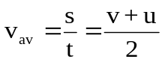
Acceleration | 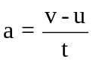
Momentum | 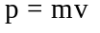
Force | 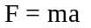
Weight | 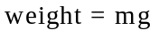
Work done | 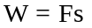
Kinetic energy | 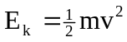
Gravitational potential energy | 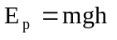
Equations of motion | 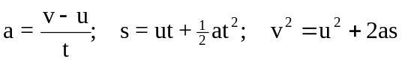
Centripetal acceleration | 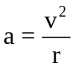
Centripetal force | 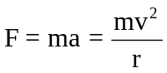
Newton’s Law of Universal Gravitation | 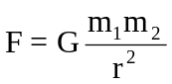
Gravitational field strength | 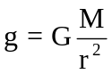

Area of Study: Structure and Materials
Moment of a force | 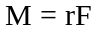
Principle of moments | 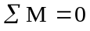
Stress | 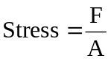
Strain | 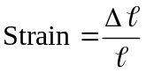
Young’s Modulus | 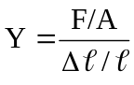

Area of Study: Electric Power
Power | 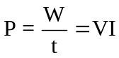
Electric current | 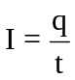
Work | 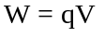
Ohm’s Law | 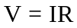
Resistances in Series | 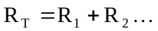
Resistances in Parallel | 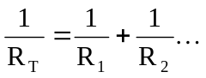
Magnetic flux | 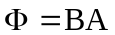
Electromagnetic induction | emf 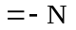 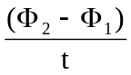  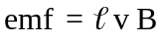
Magnetic force | 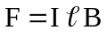
Transformer turns ratio | 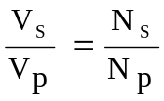

Area of Study: Sound Waves
Period | 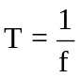
Speed, frequency, wavelength | 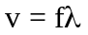
Beats | 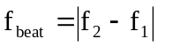
Intensity and levels | 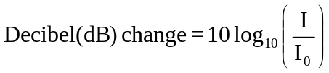  Where 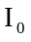 is taken as the hearing threshold = 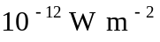
Standing waves | nodal separation 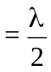
Area of Study: Atomic Physics
Energy of photons | 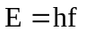
Magnetic force | 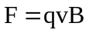

Physical Constants
Speed of light in air c = 3.00 x 10⁸ m s⁻¹
Electron charge e = -1.60 x 10⁻¹⁹ C
Mass of electron m_{e} = 9.11 x 10⁻³¹ kg
Planck's constant h = 6.63 x 10⁻³⁴ J s
Universal gravitational constant G = 6.67 x 10⁻¹¹ N m² kg⁻²
Electron volt 1 eV = 1.60 x 10⁻¹⁹ J
Mass of proton m_{p} = 1.67 x 10⁻²⁷ kg

Physical Data

Acceleration due to gravity on Earth g = 9.80 m s⁻²
Acceleration due to gravity on the Moon g_{M} = 1.62 m s⁻²
Radius of the Earth R_{E} = 6.37 x 10⁶ m
Mass of the Earth M_{E} = 5.98 x 10²⁴ kg
Radius of the Sun R_{S} = 6.96 x 10⁸ m
Mass of the Sun M_{S} = 1.99 x 10³⁰ kg
Radius of the Moon R_{M} = 1.74 x 10⁶ m
Mass of the Moon M_{M} = 7.35 x 10²² kg
Earth-Moon distance 3.84 x 10⁸ m
Earth-Sun distance 1.50 x 10¹¹ m
Tonne 1 tonne = 1.00 x 10³ kg

Speed of sound in selected substances

Substance |  |  | Velocity  m s⁻¹ | Substance |  |  | Velocity  m s⁻¹ | Substance |  |  | Velocity  m s⁻¹
Gases (25°C, 101.3 kPa) |  |  |  | Liquids (25°C) |  |  |  | Solids (thin rods)
 | air, dry | 3.46 x 10² |  |  | glycerol | 1.90 x 10³ |  |  | aluminium | 5.00 x 10³
 | carbon dioxide | 2.69 x 10² |  |  | kerosene | 1.32 x 10³ |  |  | brass | 3.48 x 10³
 | helium | 9.85 x 10² |  |  | water, distilled | 1.50 x 10³ |  |  | brick | 3.65 x 10³
 | nitrogen | 3.49 x 10² |  |  | water, sea | 1.53 x 10³ |  |  | copper | 3.81 x 10³
 | oxygen | 3.30 x 10² |  |  |  |  |  |  | iron | 5.20 x 10³

Young’s modulus and the breaking stress for selected materials.

Material | Young modulus  x 10¹¹ Pa | Breaking stress  x 10⁸ Pa
aluminium | 0.70 | 2.4
copper | 1.16 | 4.9
brass | 0.90 | 4.7
iron (wrought) | 1.93 | 3.0
mild steel | 2.10 | 11.0
glass | 0.55 | 10
tungsten | 4.10 | 20
bone | 0.17 | 1.8

Electromagnetic spectrum

 | Wavelength
λ (m) |  | 10² |  | 10 |  | 1 |  | 10⁻¹ |  | 10⁻² |  | 10⁻³ |  |  |  | 10⁻⁴ |  | 10⁻⁵ |  | 10⁻⁶ |  | 10⁻⁷ |  | 10⁻⁸ |  |  | 10⁻⁹ |  |  | 10⁻¹⁰ |  |  |  | 10⁻¹¹
microwaves
radio frequencies
infrared radiation
ultraviolet
radiation
X-rays
gamma rays


Area of
Spectrum
f(Hz) | 10⁶ |  | 10⁷ |  | 10⁸ |  | 10⁹ |  | 10¹⁰ |  | 10¹¹ |  |  | 10¹² |  |  | 10¹³ |  | 10¹⁴ |  | 10¹⁵ |  | 10¹⁶ |  | 10¹⁷ |  |  |  | 10¹⁸ |  |  | 10¹⁹ |  |  |  | 10²⁰
 | Frequency

Note: 1. Shaded areas represent regions of overlap.

2. Gamma rays and X-rays occupy a common region.

Mathematical expressions
B
c
a
Given ax² + bx + c = 0, 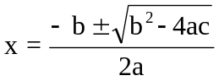
b
A
C

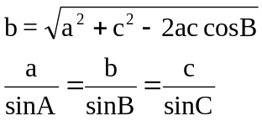

Prefixes of the Metric System

Factor | Prefix | Symbol | Factor | Prefix | Symbol
10¹²  10⁹  10⁶  10³ | tera  giga  mega  kilo | T  G  M  k | 10⁻³  10⁻⁶  10⁻⁹  10⁻¹² | milli  micro  nano  pico | m  µ  n  p

